Guide to the Papers of
The National Committee to Abolish the Poll Tax*
*(Formally Known As: Guide to the Papers of Virginia Foster Durr)

Prepared by Dana Chandler, 2007

Tuskegee University Archives and Museums

Tuskegee, AL 36088

Tuskegee Archives and Museums

©2007, Tuskegee University. All rights reserved.

TABLE OF CONTENTS

Collection Summary

Administrative Information

Index Terms

Biography

Scope and Content

Arrangement

Restrictions

Inventory

Collection Summary

Creator: The National Committee to Abolish the Poll Tax
Title: Papers of the National Committee to Abolish the Poll Tax
Dates: 1940-48
Quantity: 12.1 linear feet
Identification:
Abstract: The National Committee to Abolish the Poll Tax (1940-1948) was an organization that sought, through grass-roots efforts, to repeal the National, as well as state, poll tax.
Contact Information: Tuskegee University Archives and Museums
Tuskegee University
Tuskegee, AL 36088 USA
Phone: (334) 725-2383
Fax: (334)
Email: archives@tuskegee.edu
URL: www.tuskegee.edu

Administrative Information

Preferred Citation

Papers of the National Committee to Abolish the Poll Tax

Acquisition Information

Papers were acquired by the Tuskegee Archives from the estate of Virginia Foster Durr.

Processing Information

The papers were received in twenty two, over-stuffed, 1/3 c.f. archival boxes. There is no evidence that original order had been preserved. During processing in 2007, metal fasteners were removed and the documents were placed in acid-free folders. Copies were made of newspaper clippings and poor quality paper documents onto acid free paper. When possible and if applicable, the file title was taken from the original file folder. Since no original order was apparent, an order was imposed and series were created according to the subject matter of the records. Original file names were preserved as they were found on the folders. Blank folders were assigned titles according to the contents of the original folder. These artificial titles are noted in the inventory with square brackets.

Index Terms

This collection is indexed under the following headings in the Tuskegee University Libraries online catalog. Researchers seeking materials about related subjects, persons, organizations or places should search the catalog using these headings.

Corporation Names
Congress of Industrial Organizations
National Committee to Abolish the Poll Tax
Women's Division of the Democratic National Committee
Subjects:
African American political activists—History
African Americans—Civil rights—Alabama
African Americans—Southern States—Economic conditions
African Americans—Southern States—Social conditions
Alabama—Politics and government
Tuskegee (Ala.)
Tuskegee (Ala.)—Race relations
Leadership Conference on Civil Rights
NAACP National Conference on Black Power
Poll Tax
Segregation
Social work with African Americans
Southern States—Politics and government
United States—Economic policy--1933-1945
United States—Politics and government--1933-1945
United States—Race relations
Voter registration—Alabama
Voting
Persons:

Bethune, Mary Jane McLeod, 1875-1955
Charlton, Louise O.
Connor, Theophilus Eugene "Bull," 1897-1973
Dombrowski, James A., (James Anderson), 1897-1983
Durr, Virginia Foster
Farley, Jim, (James Aloysius), 1888-1976
Gelders, Joseph
Lamar, Rachel
Lewis, John L., (John Llewellyn), 1880-1969
Mason, Lucy Randolph, 1882-1959
Morgan, Roberta
Perry, Jennings, 1900-
Roosevelt, Eleanor, 1884-1962
Roosevelt, Franklin Delano, 1882-1945
Schryver, Kathryn
Smith, Ed "Cotton"

Agency History

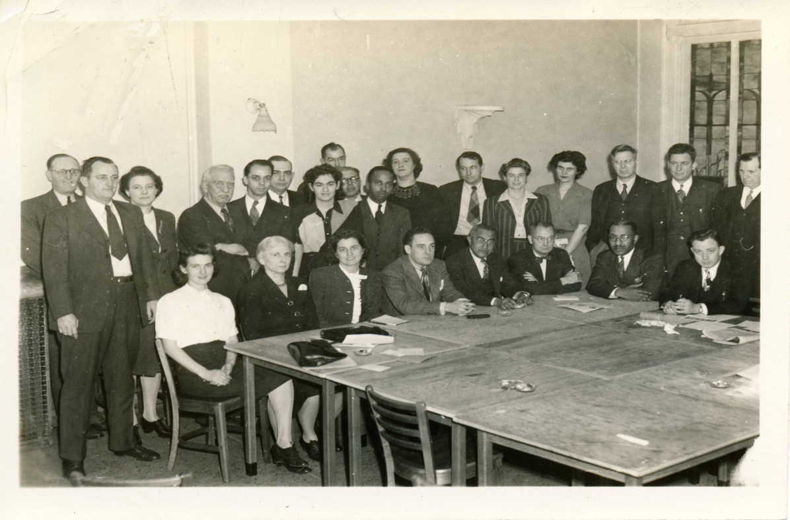
Figure 1: Photo taken at an organizational meeting of the National Committee to Abolish the Poll Tax. Location was possibly at Mid-Western field office in Chicago, Illinois in 1945.
Introduced shortly after the American Revolution, the poll or capitation (head) tax was levied by state and local governments on all male citizens as a required sum that had to be paid before one could vote. Originally adopted by all states, the poll tax became an effective means to disenfranchise both women and minorities from voting. Although several states repealed the original tax, reconstruction in the South saw the advent of the cumulative poll tax which required white and black men between the ages of 21 and 60 years of age to pay a certain sum of money for every year since their twenty-first birthday, or since the law took effect. Often, these laws were amended to require proof that the poll tax had been paid over the entire period prior to voting in current elections.
Efforts to repeal such laws were active throughout the 1940s, 1950s and early 1960s. Although the national House of Representatives passed bills repealing the poll tax five times during the 1940s, Senators from certain Southern states continued to filibuster, thereby preventing any ratification by the U.S. Senate. It was not until the Twenty-Fourth Amendment was ratified in 1964 that the poll tax was abolished from national elections. Furthermore, it was not until two years later, because of the landmark case Harper v. Virginia Board of Elections, that state poll taxes were ruled in violation of the Equal Protection Clause of the Fourteenth Amendment and subsequently abolished.
At the forefront of the efforts to repeal the poll tax was the National Committee to Abolish the Poll Tax (NCAPT), which was formed in 1940 by Lee Geyer, Democratic Congressman from California’s 17th district, in an attempt to secure backing for his Federal anti-poll tax bill, which he had recently introduced into Congress. The NCAPT utilized grass-roots campaigns, newsletters, pamphlets and personal letters, and leading social activists in an attempt to repeal the National poll tax. In 1945, they swayed a majority in the House of Representatives to repeal the poll tax, but it would flounder in the Senate until majorities from both houses sought its repeal in the early 1960s. The NCAPT closed and disbanded in the summer of 1948.
Key social activists included: Virginia Foster Durr (a founding member of the Southern Conference on Human Welfare. She served as the vice-chairman of the Civil Rights Committee, a subcommittee to abolish the poll tax); Katherine Shryver (Editor and Executive Secretary of The Poll Tax Repealer); Dr. Mary McLeod Bethune (first president and co-founder of Bethune-Cookman University); and Jennings Perry (editor of the Nashville Tennessean). It was through the efforts of individuals such as these and others, that successive generations were emboldened to press further for equal rights for all men and women.

Scope and Contents

The collection consists of documents generated or received by The National Committee to Abolish the Poll Tax, 1940-1964. The bulk of the records date between 1942 and 1946; with some dated as early as 1941. They include correspondence, newspaper clippings, articles, pamphlets and other miscellaneous documents. The records are potentially valuable to those interested in researching a history of sociological thought regarding the lives of rural Southern poor and African Americans, Democratic thought and the history of the Civil Rights Movement.

Arrangement

The documents are arranged into one series.

Series I: National Committee to Abolish the Poll Tax correspondence, notes, agendas, pamphlets, articles, posters, newspaper clippings, etc. 1941-1948.

Restrictions

Restrictions on Access

There are no restrictions on these papers.

Restrictions on Use

Researchers are responsible for addressing copyright issues on materials not in the public domain.

Inventory

Series I. National Committee to Abolish the Poll Tax correspondence, notes, agendas, pamphlets, articles, posters, newspaper clippings, etc. 1941-1948.

Box Folder

1 1 Alabama
1 2 Alabama
1 3 Arizona
1 4 Arkansas
1 5 Arkansas
1 6 California
1 7 California
1 8 California
1 9 Colorado
1 10 Colorado
1 11 Connecticut
1 12 Connecticut

Box Folder

2 1 Delaware
2 2 Delaware
2 3 District of Columbia
2 4 District of Columbia
2 5 District of Columbia
2 6 District of Columbia
2 7 District of Columbia
2 8 Florida
2 9 Florida
2 10 Georgia
2 11 Georgia

Box Folder

3 1 Idaho
3 2 Illinois
3 3 Illinois
3 4 Indiana
3 5 Indiana
3 6 Iowa
3 7 Iowa
3 8 Kansas
3 9 Kentucky
3 10 Kentucky
3 11 Louisiana
3 12 Louisiana

Box Folder

4 1 Maine
4 2 Maine
4 3 Maryland
4 4 Maryland
4 5 Massachusetts
4 6 Massachusetts
4 7 Michigan
4 8 Michigan
4 9 Minnesota
4 10 Minnesota
4 11 Mississippi
4 12 Mississippi
4 13 Missouri
4 14 Missouri
4 15 Montana
4 16 Montana

Box Folder

5 1 Nebraska
5 2 Nevada
5 3 Nevada
5 4 New Hampshire
5 5 New Hampshire
5 6 New Jersey
5 7 New Jersey
5 8 New Mexico
5 9 New Mexico

Box Folder

6 1 New York
6 2 New York
6 3 New York
6 4 New York
6 5 New York
6 6 New York
6 7 New York

Box Folder

7 1 New York
7 2 New York
7 3 New York
7 4 New York
7 5 North Carolina
7 6 North Carolina
7 7 North Dakota
7 8 Ohio
7 9 Ohio
7 10 Oklahoma
7 11 Oklahoma
7 12 Oregon
7 13 Oregon

Box Folder

8 1 Pennsylvania
8 2 Pennsylvania
8 3 Rhode Island
8 4 Rhode Island
8 5 South Carolina
8 6 South Carolina
8 7 South Dakota
8 8 Tennessee
8 9 Tennessee
8 10 Tennessee
8 11 Texas
8 12 Texas

Box Folder

9 1 Utah
9 2 Vermont
9 3 Virginia
9 4 Virginia
9 5 Washington
9 6 Washington
9 7 West Virginia
9 8 Wisconsin
9 9 Wisconsin
9 10 Wyoming
9 11 Foreign
9 12 Midwest Office (Chicago, Illinois)

Box Folder

10 1 Personal, Virginia Durr
10 2 Personal, Sara d’ Avila
10 3 Services
10 4 Herman Finch and Associates
10 5 Job Files
10 6 By Laws
10 7 Executive Board

Box Folder

11 1 Abolish Poll Tax Week
11 2 Miscellaneous, 1941-1943
11 3 Virginia Forster Durr, Personal
11 4 Bender Dinner, 2-24-48
11 5 Bender Letter, 2-3-48
11 6 Constitutional Amendment
11 7 Requests for New Handbook
11 8 Conference 10-45
11 9 Conference 10-45
11 10 Correspondence- Progressive Party Candidates

Box Folder

12 1 Press Releases, 1945-1948
12 2 Publicity Ideas
12 3 Clippings, 1947 and 1948
12 4 1940 Census Data
12 5 Economic Data
12 6 Soldier Voting
12 7 Primaries

Box Folder

13 1 Movies or Films, APT
13 2 Speeches Made, Editorials
13 3 Speeches, Radio Scripts
13 4 Speeches, Radio Scripts
13 5 Speeches, Radio Scripts

Box Folder

14 1 Elections, 1948
14 2 Misc. Articles on Poll Tax, George H. Bender
14 3 Misc. Articles on Poll Tax, George H. Bender
14 4 Miscellaneous Articles, Jennings Perry and Others
14 5 Proceedings, Conference on Anti-Poll Tax Education
14 6 Bibliographies
14 7 Proceedings, Conference on Anti-Poll Tax Education
14 8 History of The National Committee to Repeal The Poll Tax and Photo

Box Folder

15 1 A.F.I., 1943-1946
15 2 Independent Unions
15 3 Farm Organizations, 1943-1946
15 4 Miscellaneous Organizations, 1943-1946
15 5 C.I.O, 1943-1946
15 6 C.I.O, 1943-1946
15 7 C.I.O, 1943-1946
15 8 C.I.O, 1943-1946

Box Folder

16 1 Church Organizations, 1943-1946
16 2 Church Organizations, 1943-1946
16 3 Administration, National Political Parties
16 4 Women’s Organizations, 1943-1946
16 5 YMCA-YWCA, 1943-1946
16 6 Civil Rights Groups, 1943-1946
16 7 Negro Organizations
16 8 Railroad Brotherhoods, 1943-1946
16 9 Veteran’s Organizations
16 10 Negro Organizations

Box Folder

17 1 Index Cards, Boule-Columnists

Box Folder

18 1 Index Cards, A-Z

Box Folder

19 1 Index Cards, Newspaper for Press Releases- Members Fairfax, Vax

Box Folder

20 1 Index Cards, A-Z

Box Folder

21 1 Mailed Lists Special
21 2 Mailing Lists Special
21 3 Money Raising
21 4 Pre-Paid Mailing Accounts
21 5 Sponsors
21 6 Sponsors
21 7 State Sponsor, Suggestions
21 8 Sponsoring Organizations

Box Folder

22 1 January 1946, Receipts
22 2 Receipts, February 1946
22 3 Receipts, March 1946
22 4 Receipts, April 1946
22 5 Receipts, May 1946
22 6 Receipts, June 1946
22 7 Receipts, July 1946
22 8 Receipts, August, September and October 1946
22 9 Receipts, January 1947
22 10 Receipts, February 1947
22 11 Receipts, March 1947
22 12 Receipts, April 1947
22 13 Receipts, May 1947
22 14 Receipts, June 1947
22 15 Receipts, July 1947
22 16 Receipts, September 1947
22 17 Receipts, October 1947
22 18 Receipts, November 1947
22 19 Receipts, February 1948
22 20 Receipts, March 1948
22 21 Receipts, April 1948
22 22 Receipts, May 1948
22 23 Receipts, June 1948

Box Folder

23 1 Lobbying Act Forms
23 2 Field Trips, 1943
23 3 Receipts, January 1945
23 4 Receipts, February 1945
23 5 Receipts, March 1945
23 6 Receipts, April 1945
23 7 Receipts, May 1945
23 8 Receipts, June 1945
23 9 Receipts, July 1945
23 10 Receipts, August 1945
23 11 Receipts, September 1945
23 12 Receipts, October 1945
23 13 Receipts, November 1945
23 14 Receipts, December 1945
23 15 USCHW-NCRPT. Finances

Box Folder

24 1 [Voting Restrictions in the 13 Southern States: The Committee of Editors and Writers of the South]
24 2 Statistics, 1944-Current
24 3 Senate, 1945-1946
24 4 Senate, 1945-1946
24 5 Senate, 1945-1946
24 6 Senate, 1945-1946
24 7 Action Letters, 1947
24 8 Report of Proceedings- Hearing Held Before Subcommittee of the Committee on
the Judiciary, S.1280

Box Folder

25 1 House Action 1943, 78th Congress, H.R. 7
25 2 1944 Election Statistics
25 3 House Action 1945, 79th Congress, H.R. 7
25 4 House Action 1943, 79th Congress, H.R. 7
25 5 Senate Action 1947
25 6 House Action 1947
25 7 House Action 1947
25 8 House Hearings, H.R. 29, July 1947, Copies of Testimony and More
25 9 Senate Hearings, 1948

Box Folder

26 1 Constitutionality [H.R. 7, The Anti-Poll Tax Bill]
26 2 Legislative Bulletin
26 3 Constitutionality [Miscellaneous About H.R. 7, The Anti-Poll Tax Bill]
26 4 Townsend Plan, 1943-1946
26 5 Wallace Committee, State Material- Minutes, Etc.
26 6 Virginia Democratic Party Plan
26 7 Appointment of Reps. in Congress
26 8 Progressive Party- Arlington County Elections, 1949
26 9 Progressive Party- General Elections, 1949
26 10 Wires Sent During H.R. 7 Senate Fight, July 30-31, 1946
26 11 Political Information, Candidates
26 12 Misc. To Sort
26 13 1946 Election Statistics
26 14 Materials Used

Box Folder

27 1 Resolutions on Poll Tax, Adopted, Suggested
27 2 State Election Laws
27 3 State Election Laws
27 4 State Election Laws
27 5 State Election Laws
27 6 Court Cases
27 7 Supreme Court Cases

Box Folder

28 1 Poll Tax Pamphlets (1)
28 2 Poll Tax Pamphlets (2)
28 3 Poll Tax (Copies of Bills, Hearings and Reports)
28 4 Poll Tax (Copies of Bills, Hearings and Reports)
28 5 Poll Tax (Copies of Bills, Hearings and Reports)
28 6 Poll Tax Hearings
28 7 Poll Tax Hearings

Box Folder

29 1 Press Releases
29 2 Senate Action, 1944, 78th Congress, H.R. 7
29 3 Senate Action, 1944, 78th Congress, H.R. 7
29 4 Miscellaneous Articles
29 5 Documents Relating to the North Atlantic Treaty
29 6 Conference, 2-3-45
29 7 Cloture Data
29 8 Conference on Anti-Poll Tax Education, February 3, 1945

