Board of Trustees Chairmen

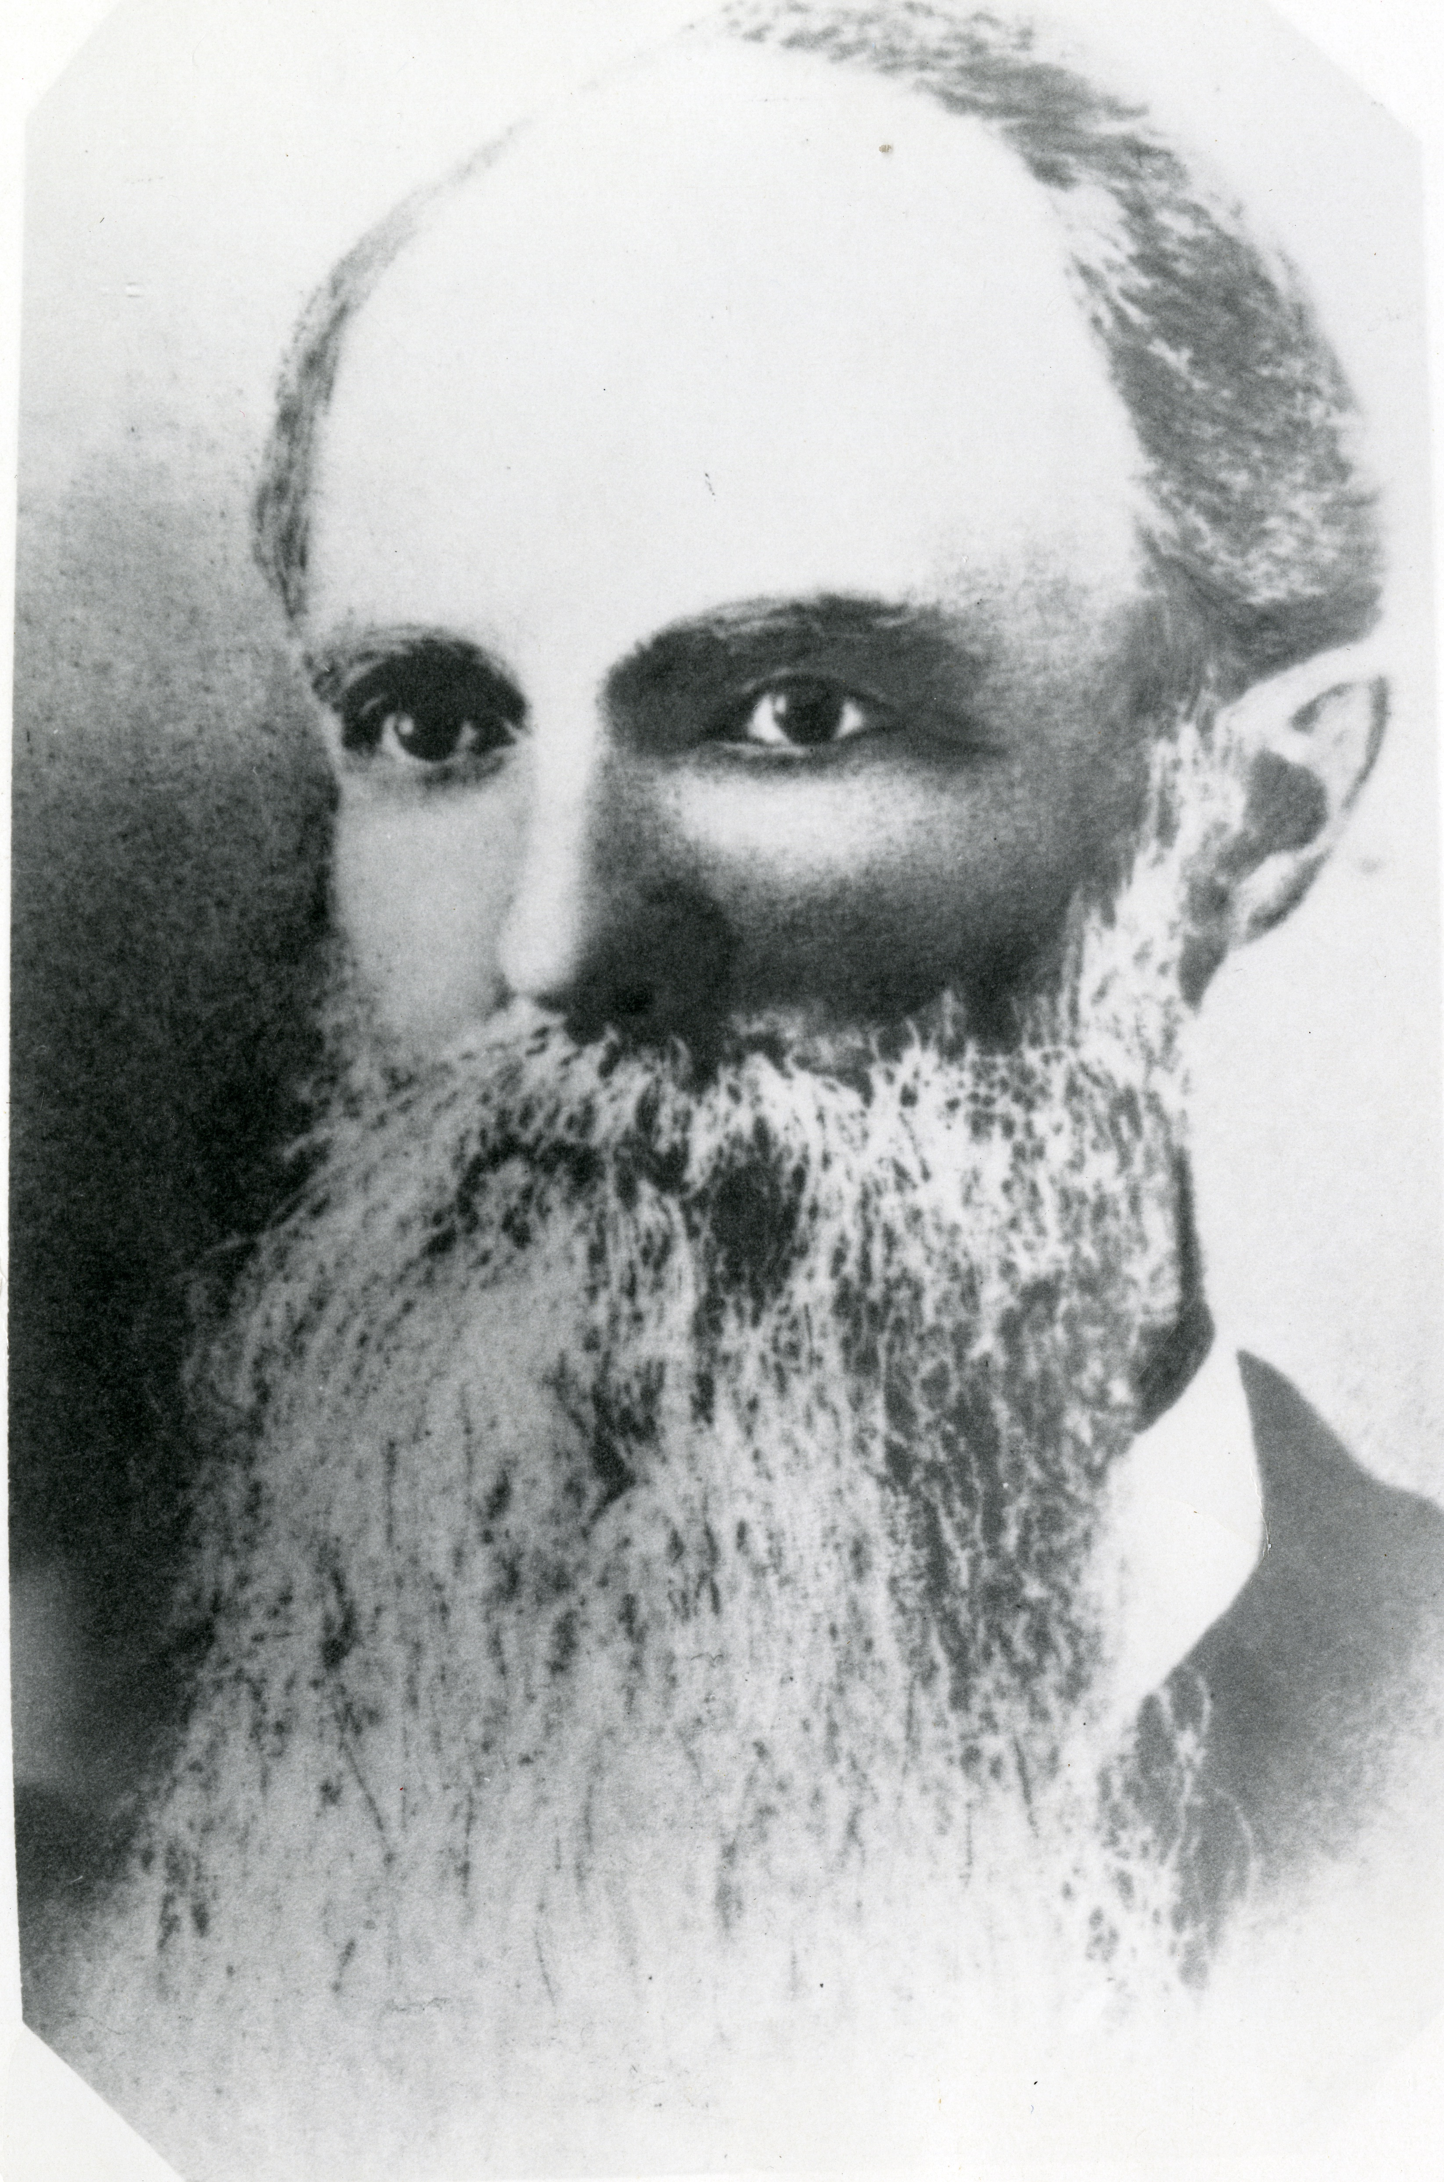

George W. Campbell
1881-1905

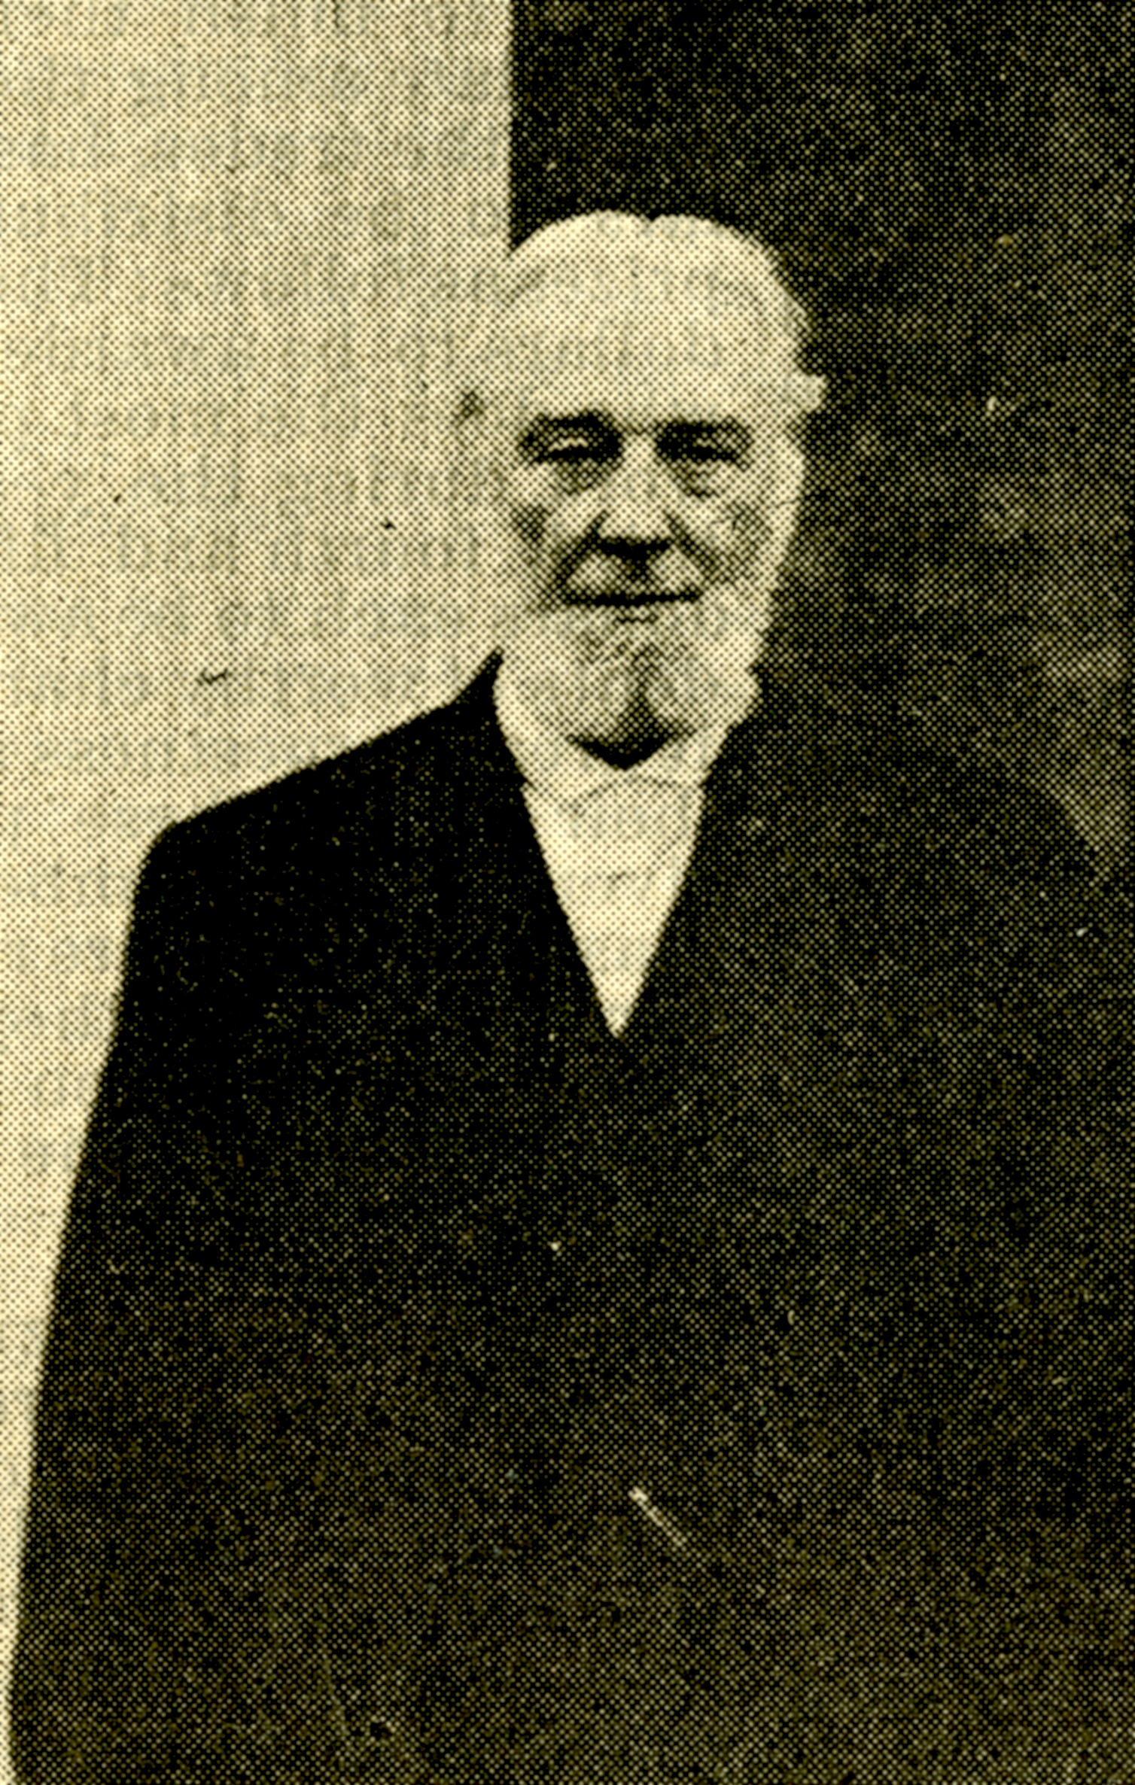

Robert C. Ogden
1905-1907

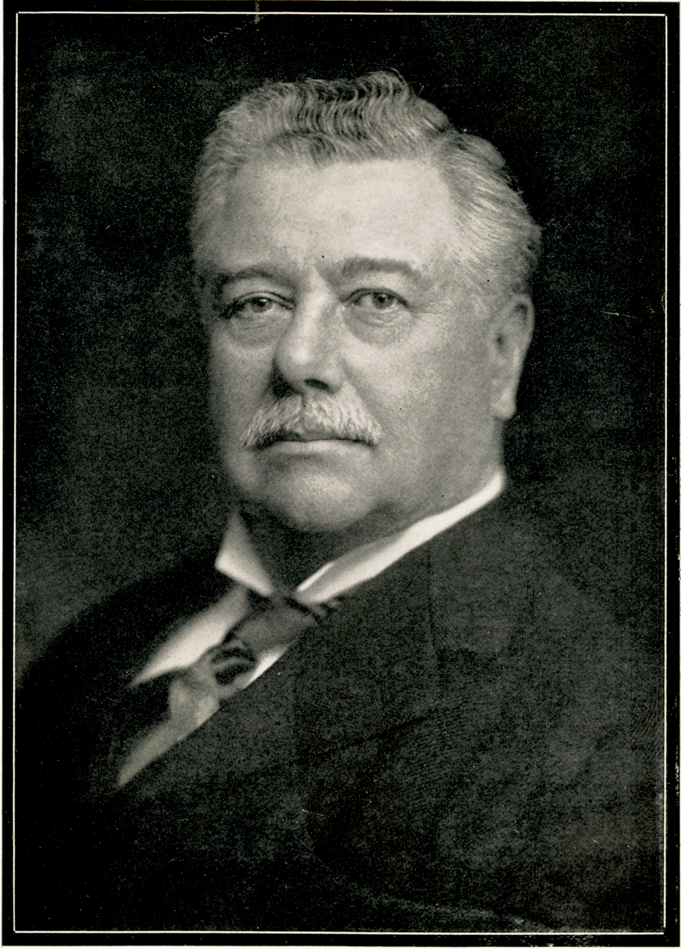

Seth Low
1907-1916

William G. Willcox
1916-1923

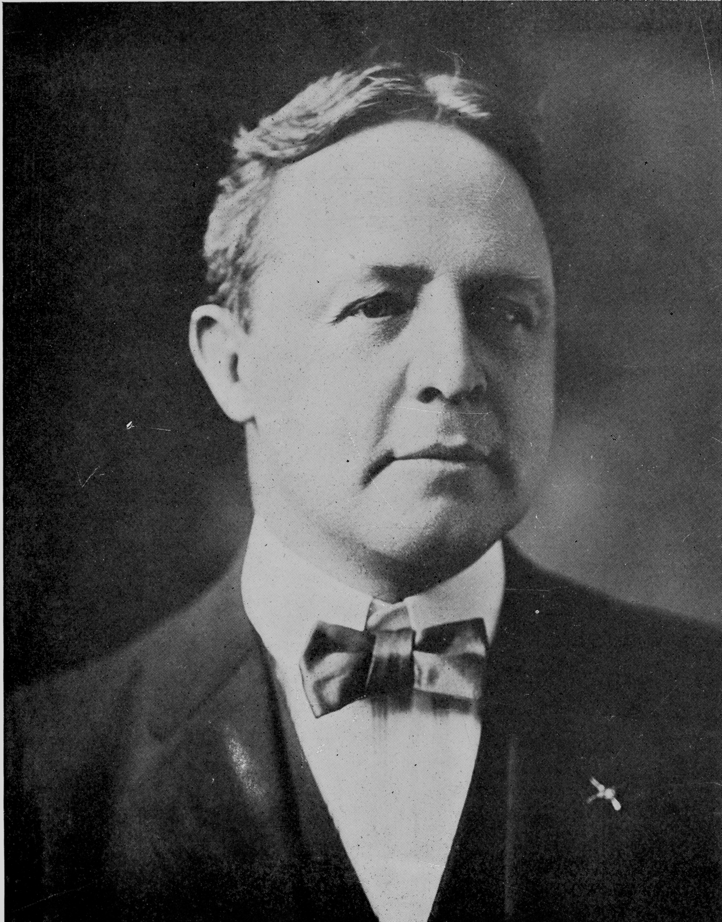

Dr. William Jay Schiefflen
1923-1945

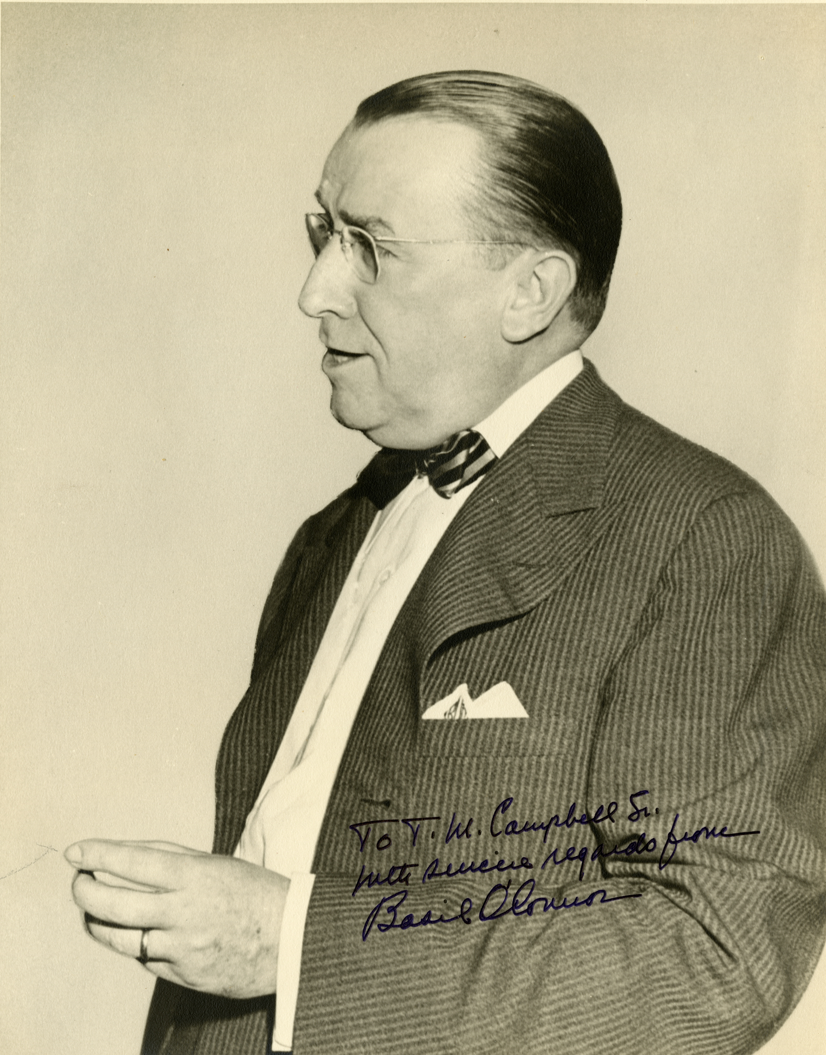

Basil O’Connor
1945-1969

Melvin A. Glasser
1969-1971 (Acting Chair)

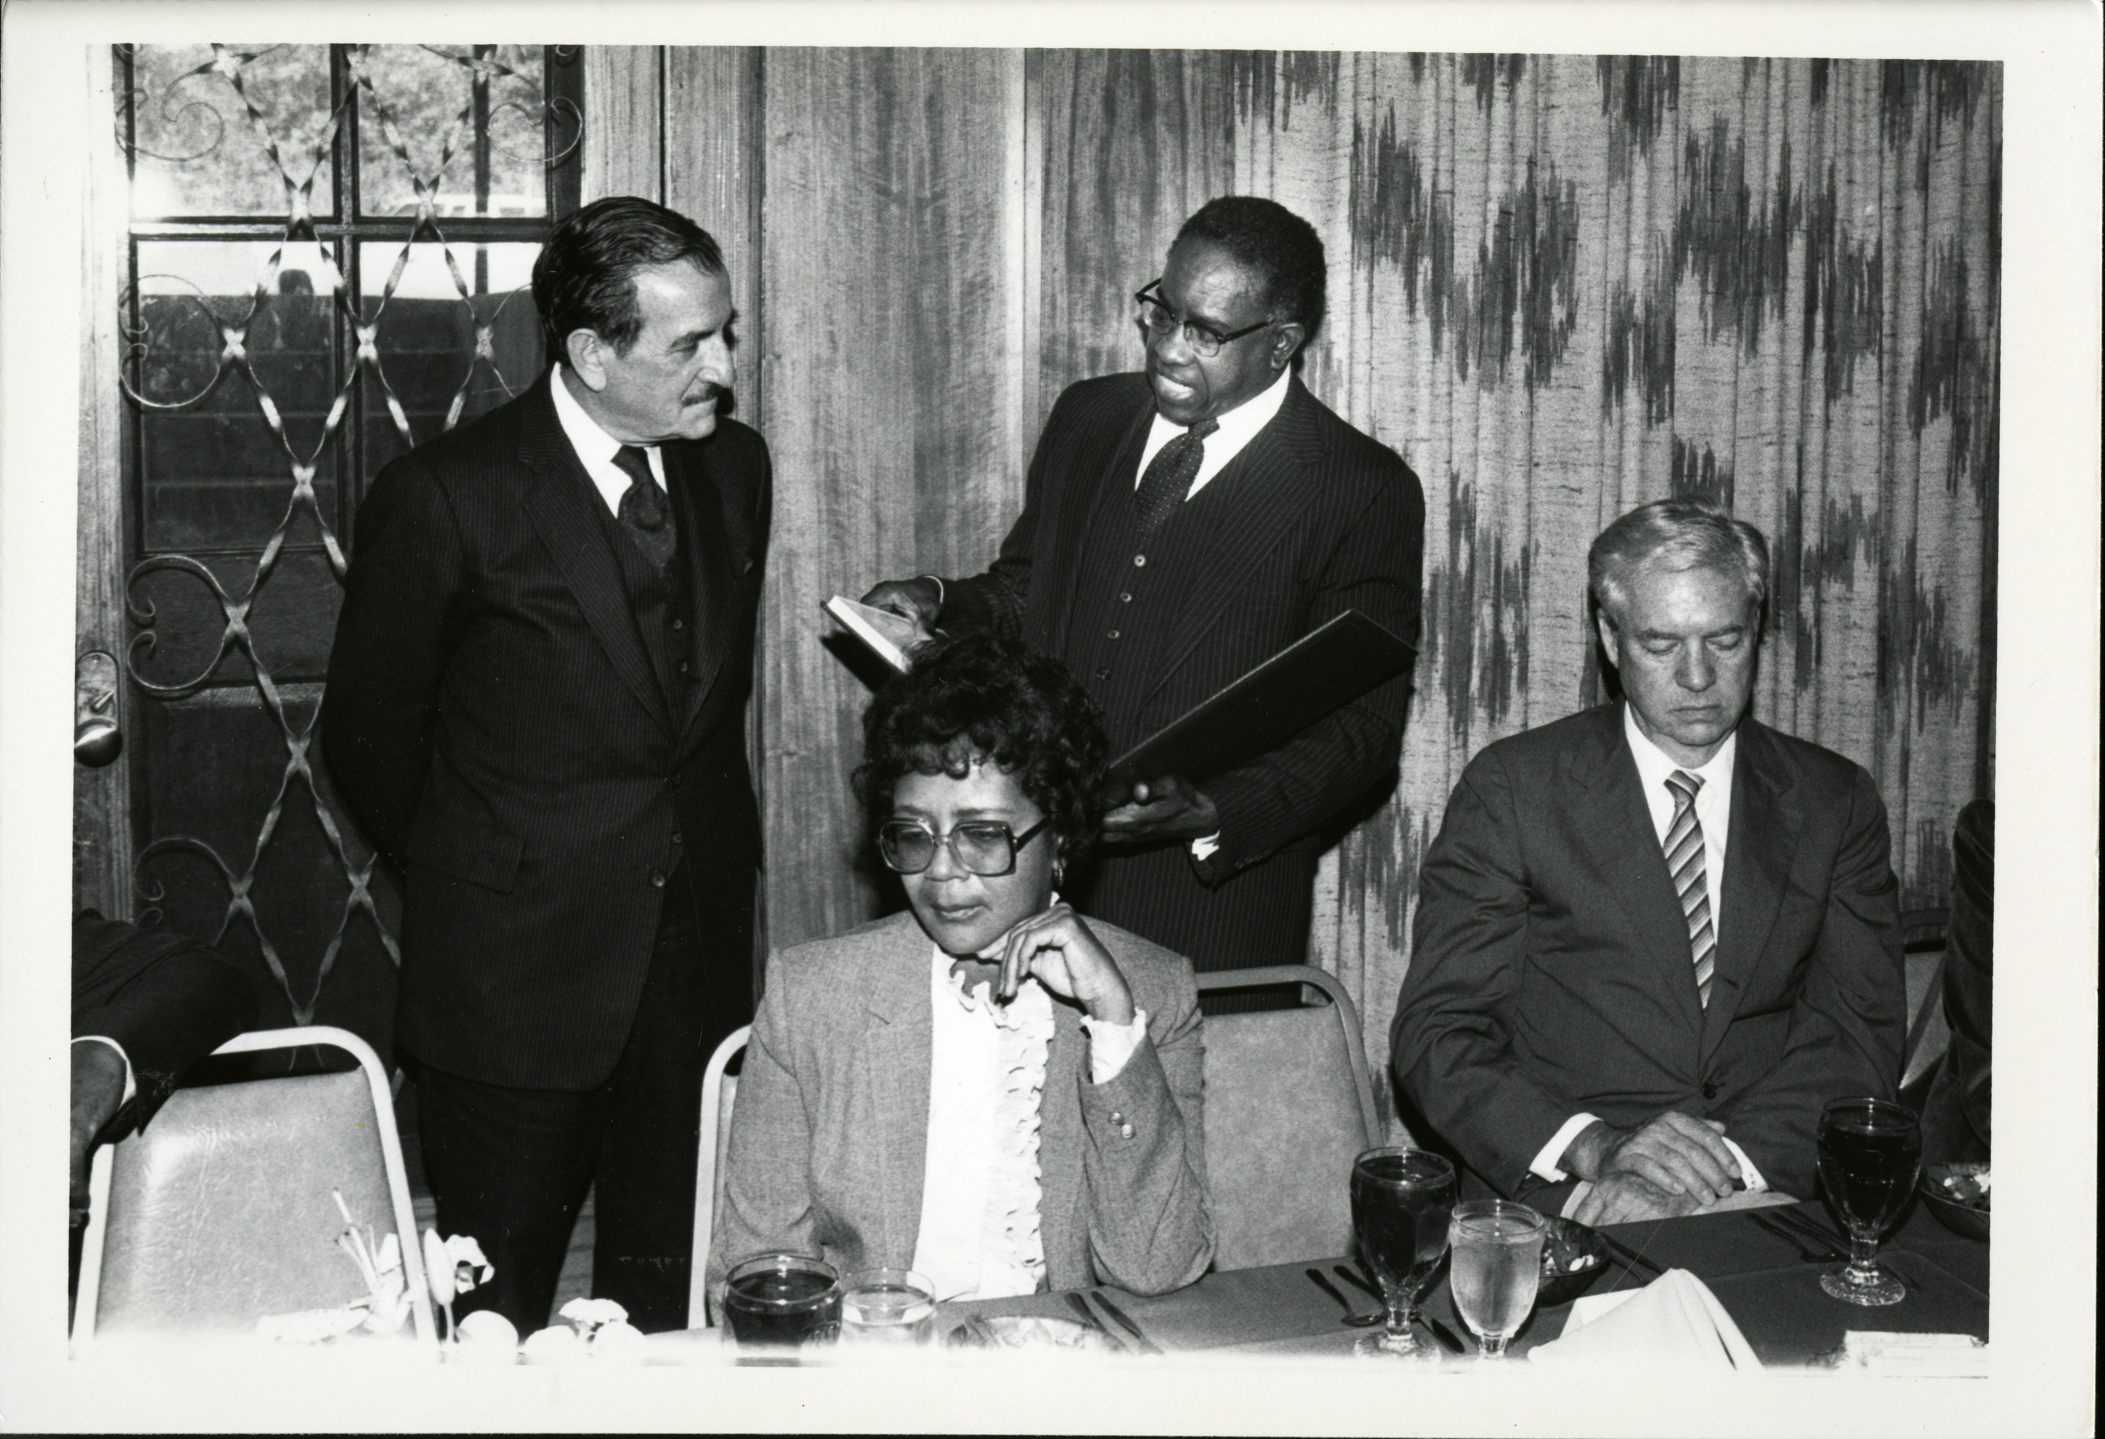

Melvin A. Glasser
1972-1982

Andrew J. Brimmer
1983-2010

